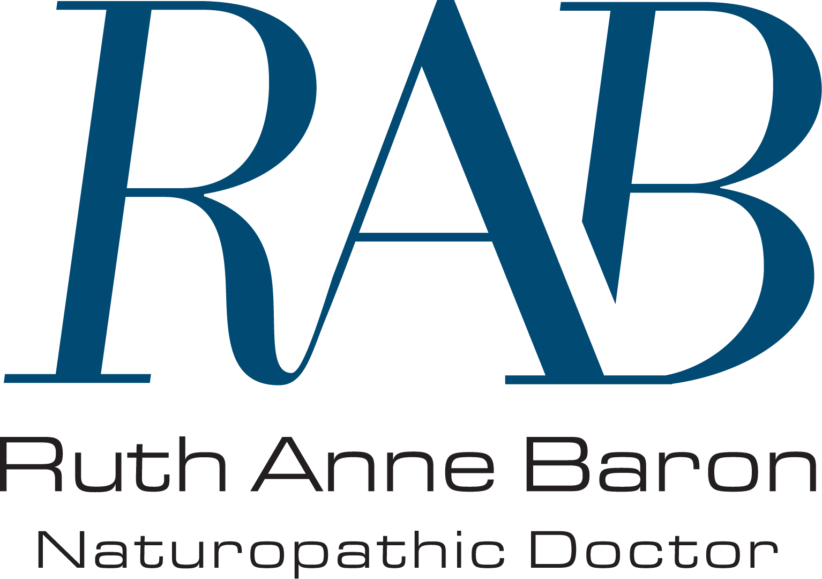
PEDIATRIC INTAKE FORM

Parent/Guardian, please take the time to accurately complete this questionnaire. The information you contribute is valuable in providing effective health care for your child.

Name: _________________________________ Date: _______________________________
Parent/Guardian: _________________________ Phone: ______________________________
Address: ______________________________________________________________________
Age: _________ Date of Birth: ____________ Weight: __________ Height: ___________
What are your chief concerns regarding your child’s health? __________________________________
____________________________________________________________________________________________________________________________________________________________________
If there is a specific condition, when did it start? _______________________________________
List practitioners seen for this condition: _____________________________________________
_____________________________________________________________________________
Is there a family history of this condition? ____________________________________________
List any other supplements, medications, homeopathic/botanical preparations your child is currently taking, and dosages: _____________________________________________________
_____________________________________________________________________________
List any major illnesses, surgeries, hospitalizations, x-rays your child has received: ___________
____________________________________________________________________________________________________________________________________________________________________
When was your child last well? _________________________________________________________

Family History: Please check appropriate box and indicate which family member.
◻ Alcoholism ◻ Cancer ◻ Heart Disease ◻ Schizophrenia
◻ Allergies ◻ Cataracts ◻ Hyperactivity ◻ Stomach Ulcers
◻ Arteriosclerosis ◻ Celiac Disease ◻ Kidney Disease ◻ Stroke
◻ Arthritis ◻ Colitis ◻ Learning Disability ◻ Tuberculosis
◻ Asthma ◻ Depression ◻ Mental Disease ◻ Yeast Infections
◻ Bed Wetting ◻ Diabetes ◻ Muscular Dystrophy ◻ Venereal Disease
◻ Birth Defects ◻ Epilepsy ◻ Multiple Sclerosis ◻ Other

Prenatal History:

Mother’s age at child’s birth: ___________
Please check appropriate boxes regarding mother’s pregnancy
◻ Alcohol use ◻ Diabetes ◻ Illnesses ◻ Physical or emotional
◻ Bleeding ◻ Drug use ◻ Medications trauma
◻ Cigarette Use ◻ Hypertension ◻ Nausea ◻ Thyroid problems
List any supplements/vitamins taken during pregnancy ___________________________________
_______________________________________________________________________________
Did the mother smoke before the pregnancy? If so, how many? ____________________________
Does anyone in the household currently smoke? ________________________________________
Mother’s diet during pregnancy was: ◻ poor ◻ fair ◻ good ◻ excellent
Mother’s emotional state during pregnancy: ◻ excellent ◻ stable ◻ stressed
Emotional climate of present household: ◻ excellent ◻ stable ◻ stressed

Birth History:

◻ Full Term ◻ Premature ◻ Late
How was the birth? Please list whether home/hospital, vaginal/C-section, any interventions (forceps, epidural, etc), and any complications __________________________________________
_______________________________________________________________________________
Child’s weight: ___________ Length: __________ Length of Labour: ___________________
Check any of the following if they occurred at birth or soon after:
◻ Birth defects ◻ Colic ◻ Rashes
◻ Birth injuries ◻ Jaundice ◻ Seizures
Other: _________________________________________________________________________

General Information:

Child’s sleep patterns in the first year: ________________________________________________
Child’s sleep patterns presently: _____________________________________________________
Does your child: ◻ wake early ◻ have difficulty falling asleep ◻ have nightmares/terrors

Feeding: ◻ breast-fed How long? ________ ◻ formula dairy/soy (please circle)
What solid foods were started prior to 6 months of age? __________________________________
_______________________________________________________________________________
List your child’s favourite foods: _____________________________________________________
List any food sensitivities/allergies: ___________________________________________________

Your child’s appetite is: ◻ poor ◻ fair ◻ good
North Toronto Natural Health Clinic Informed Consent

Naturopathic Medicine is the treatment and prevention of disease by natural means. Naturopathic Doctors assess the whole person, taking into consideration physical, mental, emotional and spiritual aspects of the individual. Gentle, non-invasive techniques are generally used in order to stimulate the body’s inherent healing capacity.

A number of different approaches may be used throughout the course of treatment. Treatment modalities include diet, lifestyle counselling, clinical nutrition (primary via supplementation), botanical medicine, homeopathy, Asian medicine and acupuncture, hydrotherapy, and physical medicine

Individual diets and nutritional supplements are recommended to address deficiencies, treat disease processes, and promote health. The benefits may include increased energy, improved gastrointestinal function, enhanced immunity, and general well-being.

Botanical medicine is plant based medicine that involves the use of herbal teas, tinctures, capsules, and other forms of herbal preparations to assist in recovery from injury and disease.

Homeopathy is a form of medicine based on the Law of Similars; that is, the use of tiny doses of the very thing that causes symptoms in healthy people. These minute doses, of plant, animal, or mineral origin, are used to stimulate the body’s ability to heal itself. Homeopathy is a powerful tool that effects healing on a physical and emotional level.

Asian medicine includes the use of acupuncture, Eastern herbs and dietary changes to eliminate disease and balance body functions. Acupuncture refers to the insertion of sterilized disposable needles through the skin into underlying tissues at specific points on the body. Eastern herbs may be given in the form of pills, tinctures, or decoctions (strong teas) to be taken internally or used externally as a wash. Dietary advice is based on traditional Chinese medical theory.

Physical medicine refers to the use of hands-on techniques such as soft tissue and spinal manipulation, as well as various types of electrical stimulation and therapeutic ultrasound for the purpose of treating musculoskeletal and neurological problems.

Hydrotherapy refers to the use of hot and cold water applications to improve circulation and stimulate the immune system.

Lifestyle counselling involves identifying risk factors and making recommendations to help optimize one’s physical, mental, and emotional environment.

During your initial visits, your Naturopathic Doctor will take a thorough case history and perform a basic/complaint-oriented physical examination, and when indicated, take urine samples for further testing, or blood samples for lab investigation.

Even the gentlest therapies may cause complications in certain physiological conditions. This depends greatly on the individual and the extent of the illness. Some therapies must be used with caution in certain diseases such as diabetes, heart, liver or kidney disease. It is very important, therefore, that you inform your naturopathic doctor immediately of any disease process that you are suffering from as well as any medications (prescription or over-the-counter) that you are taking. If you are pregnant, suspect you are pregnant, or you are breast-feeding, advise your doctor immediately.

Health risks associated with Naturopathic Medicine include but are not limited to:
- Aggravation of pre-existing symptoms during the healing process.
- Allergic reactions to supplements or herbs.
- Pain, bruising or injury from venipuncture or acupuncture
- Fainting or puncturing of an organ with acupuncture needles
- Muscle strains and sprains or disc injuries from spinal manipulation

______  Initials | I understand that a record will be kept of the health services provided to me. This record will be kept confidential and will not be released to others without my consent, unless required by law. I understand that I may look at my medical record at any time and can request a copy of it by paying the appropriate fee.

______  Initials | I understand that the Naturopathic Doctor will answer any questions that I have to the best of her ability. I understand that the results are not guaranteed. I do not expect the doctor to be able to anticipate and explain all risks and complications. With this knowledge, I voluntarily consent to diagnostic and therapeutic procedures mentioned above, except for (please list any exceptions): ________________________________ _____________________________________________________________________

______  Initials | I understand that fees and supplements are to be paid for at the time of the consultation.

______  Initials | I understand that a fee will be charged (Missed Appointment Fee) for any missed appointments or cancellations with less than 24 hours notice.

As the patient, you are responsible for the total charges incurred for each visit. We accept cash, debit, cheque or visa. If you have coverage for Naturopathic Medicine, you are responsible for billing your own insurance company – we will provide you with all of the information necessary to send your claim for reimbursement.

Your Naturopathic Doctor may prescribe supplements that can be purchased from our in-house dispensary, or elsewhere. Most insurance companies do not cover the supplements that we prescribe and dispense.

I have read and understand the above-stated policies and information. I hereby authorize and consent to naturopathic treatment and examination by Ruth Anne Baron. I understand that I am free to withdraw my consent and to discontinue participation in these procedures at any time.

Patient Name (please print): ______________________________________________________
Signature of Patient or Guardian: ____________________________________________________
Date: _________________________________________________

